**PL/SQL Exercises**

**Exercise-1**

Exercise 1:

* Scenario 1:

**Solution:**

**//** For adding column isVIP in Customers table **//**

ALTER TABLE Customers ADD IsVIP VARCHAR2(5);

**//** Decrementing interest rate by 1 for customers above 60 years of age **//**

BEGIN

FOR c IN (

SELECT CustomerID

FROM Customers

WHERE FLOOR(MONTHS_BETWEEN(SYSDATE, DOB) / 12) > 60

) LOOP

UPDATE Loans

SET InterestRate = InterestRate - 1

WHERE CustomerID = c.CustomerID;

END LOOP;

DBMS_OUTPUT.PUT_LINE('Interest rates updated for customers above 60.');

END;

/

**OUTPUT:**

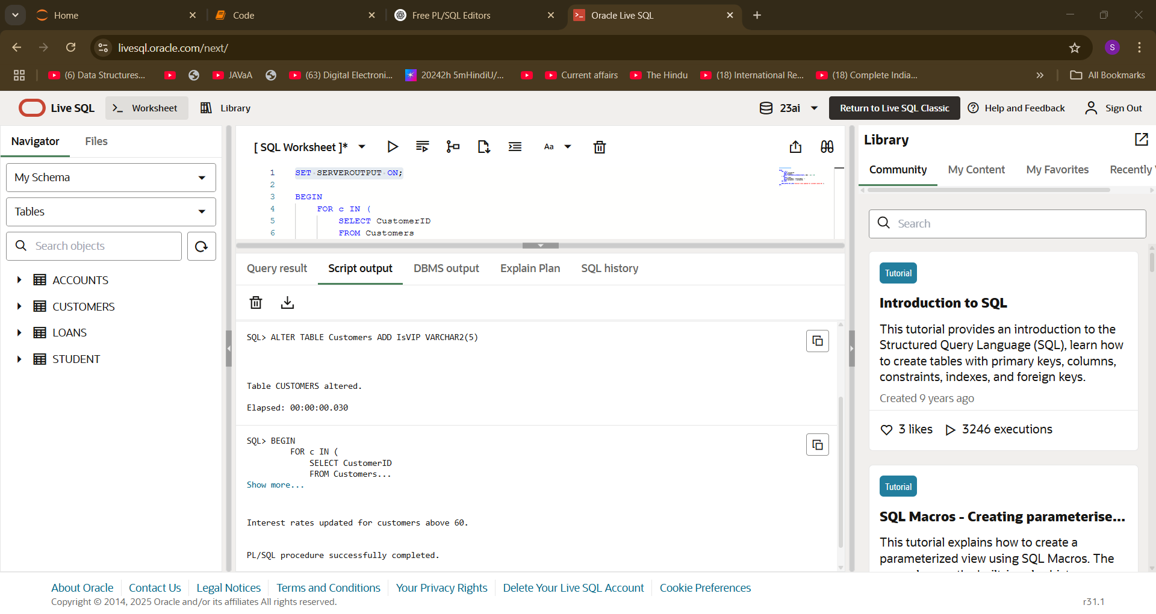

Exercise 1:

* Scenario 2:

**Solution:**

**//** Setting flag isVIP as per customer balance with threshold at 10000 **//**

BEGIN

FOR c IN (

SELECT CustomerID, Balance FROM Customers

) LOOP

IF c.Balance > 10000 THEN

UPDATE Customers

SET IsVIP = 'TRUE'

WHERE CustomerID = c.CustomerID;

ELSE

UPDATE Customers

SET IsVIP = 'FALSE'

WHERE CustomerID = c.CustomerID;

END IF;

END LOOP;

DBMS_OUTPUT.PUT_LINE('VIP status updated based on customer balance.');

END;

/

**OUTPUT:**

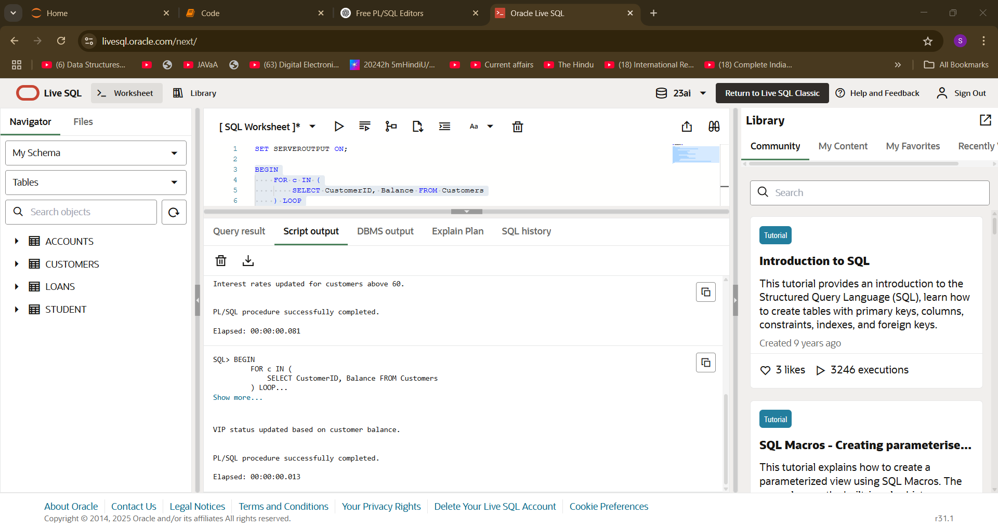

Exercise 1:

* Scenario 3:

**Solution:**

**//** Printing reminder message for customers with loan due in next 30 days **//**

BEGIN

FOR l IN (

SELECT L.LoanID, L.CustomerID, C.Name, L.EndDate

FROM Loans L

JOIN Customers C ON C.CustomerID = L.CustomerID

WHERE L.EndDate BETWEEN SYSDATE AND SYSDATE + 30

) LOOP

DBMS_OUTPUT.PUT_LINE(

'Reminder: Loan ID ' || l.LoanID ||

' for customer ' || l.Name ||

' (Customer ID ' || l.CustomerID ||

') is due on ' || TO_CHAR(l.EndDate, 'DD-MON-YYYY')

);

END LOOP;

END;

/

**OUTPUT:**

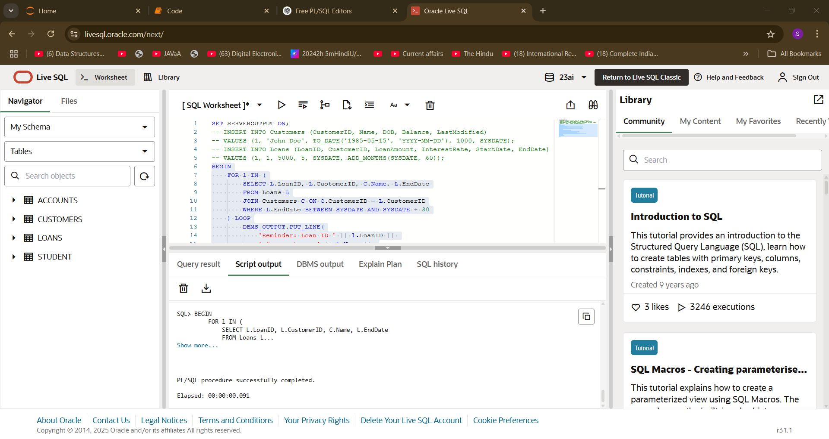

**Exercise-3**

Exercise 3:

* Scenario 1:

**Solution:**

**//** Monthly interest for all savings accounts **//**

CREATE OR REPLACE PROCEDURE ProcessMonthlyInterest AS

BEGIN

FOR acc IN (

SELECT AccountID, Balance

FROM Accounts

WHERE AccountType = 'Savings'

) LOOP

UPDATE Accounts

SET Balance = Balance + (acc.Balance * 0.01),

LastModified = SYSDATE

WHERE AccountID = acc.AccountID;

END LOOP;

DBMS_OUTPUT.PUT_LINE('Monthly interest applied to all savings accounts.');

END;

/

**OUTPUT:**

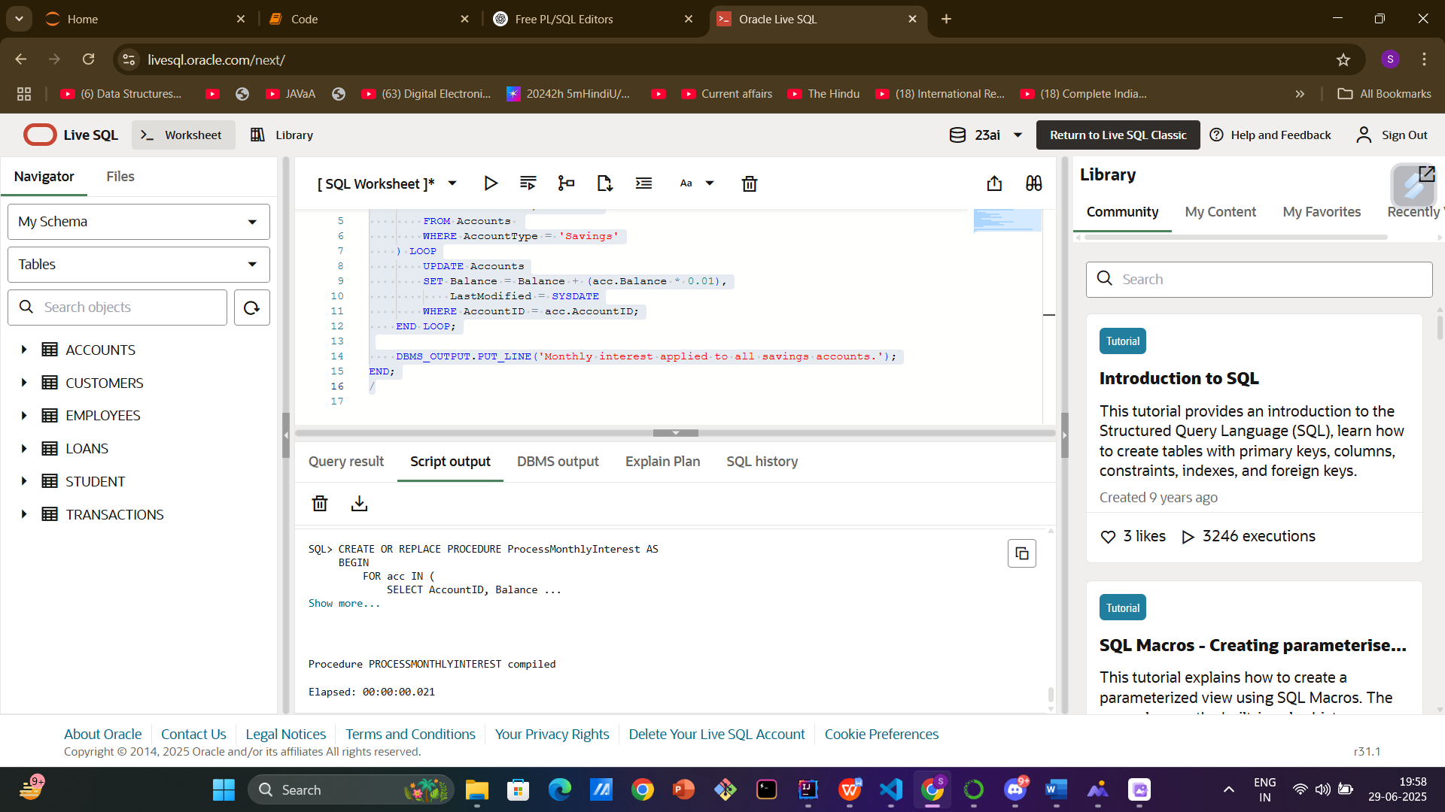

Exercise 3:

* Scenario 2:

**Solution:**

**//** Employee Bonus by Department**//**

CREATE OR REPLACE PROCEDURE UpdateEmployeeBonus (

p_department IN VARCHAR2,

p_bonus_percent IN NUMBER

) AS

BEGIN

UPDATE Employees

SET Salary = Salary + (Salary * p_bonus_percent / 100)

WHERE Department = p_department;

DBMS_OUTPUT.PUT_LINE('Bonus applied to employees in department: ' || p_department);

EXCEPTION

WHEN OTHERS THEN

DBMS_OUTPUT.PUT_LINE('Error: ' || SQLERRM);

END;

/

**OUTPUT:**

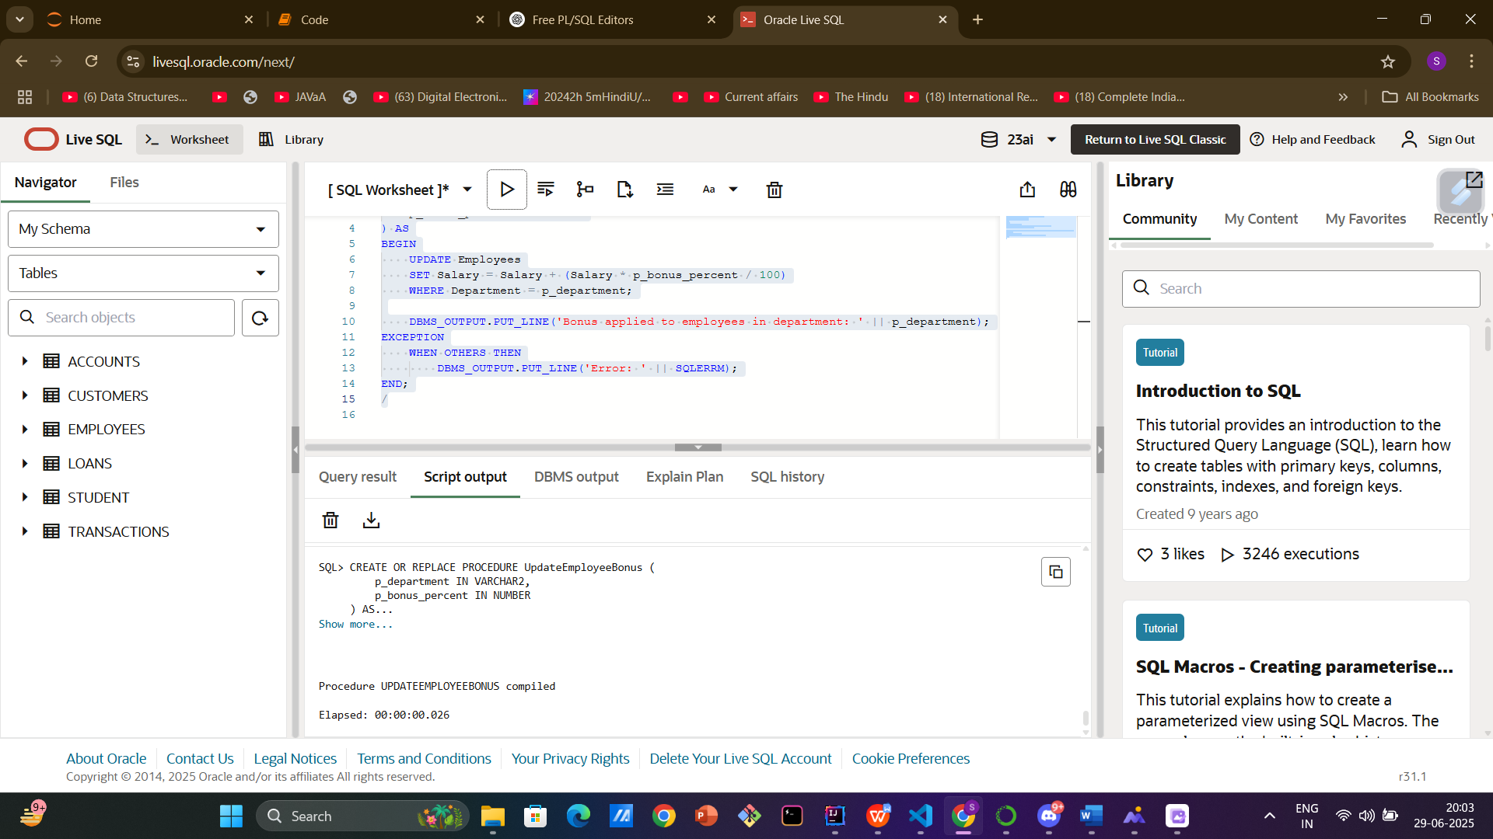

Exercise 3:

* Scenario 3:

**Solution:**

**//** Transfer funds between accounts**//**

CREATE OR REPLACE PROCEDURE TransferFunds (

p_from_account IN NUMBER,

p_to_account IN NUMBER,

p_amount IN NUMBER

) AS

v_balance NUMBER;

BEGIN

SELECT Balance INTO v_balance

FROM Accounts

WHERE AccountID = p_from_account

FOR UPDATE;

IF v_balance < p_amount THEN

RAISE_APPLICATION_ERROR(-20001, 'Insufficient balance in source account.');

END IF;

UPDATE Accounts

SET Balance = Balance - p_amount,

LastModified = SYSDATE

WHERE AccountID = p_from_account;

UPDATE Accounts

SET Balance = Balance + p_amount,

LastModified = SYSDATE

WHERE AccountID = p_to_account;

DBMS_OUTPUT.PUT_LINE('Transferred ' || p_amount || ' from Account ' || p_from_account || ' to Account ' || p_to_account);

EXCEPTION

WHEN NO_DATA_FOUND THEN

DBMS_OUTPUT.PUT_LINE('Error: One or both accounts not found.');

WHEN OTHERS THEN

DBMS_OUTPUT.PUT_LINE('Error: ' || SQLERRM);

END;

/**OUTPUT:**

